Grade 6 Computing Worksheet - Answers

Q1: Identify and explain the following Symbols with respect to flowcharts.(similar answer can be accepted)

Rectangle → Process: Used to represent a process or instruction.
Diamond → Decision: Used to represent a decision point (Yes/No, True/False).
Oval → Terminator: Used to represent Start or End of a flowchart.

Q2: Why do we use arrows in a flowchart?(similar answer can be accepted)
Arrows are used to show the direction of flow of the process from one step to another.

Q3: When do we use a parallelogram in a flowchart?(similar answer can be accepted)
A parallelogram is used to represent input or output operations (e.g., reading data or displaying output).

Q4: Scenario-Based Problem
a) Age = 20 → Ticket price = 500
b) Age = 10 → Ticket price = 300
Explanation: The algorithm checks the age entered. If it is 18 or more, the ticket price is set to 500. Otherwise, the ticket price is set to 300.

Q5: Scenario-Based Flowchart
a) Marks = 85 → Grade = A
b) Marks = 65 → Grade = B
c) Marks = 20 → Grade = F
Flowchart:
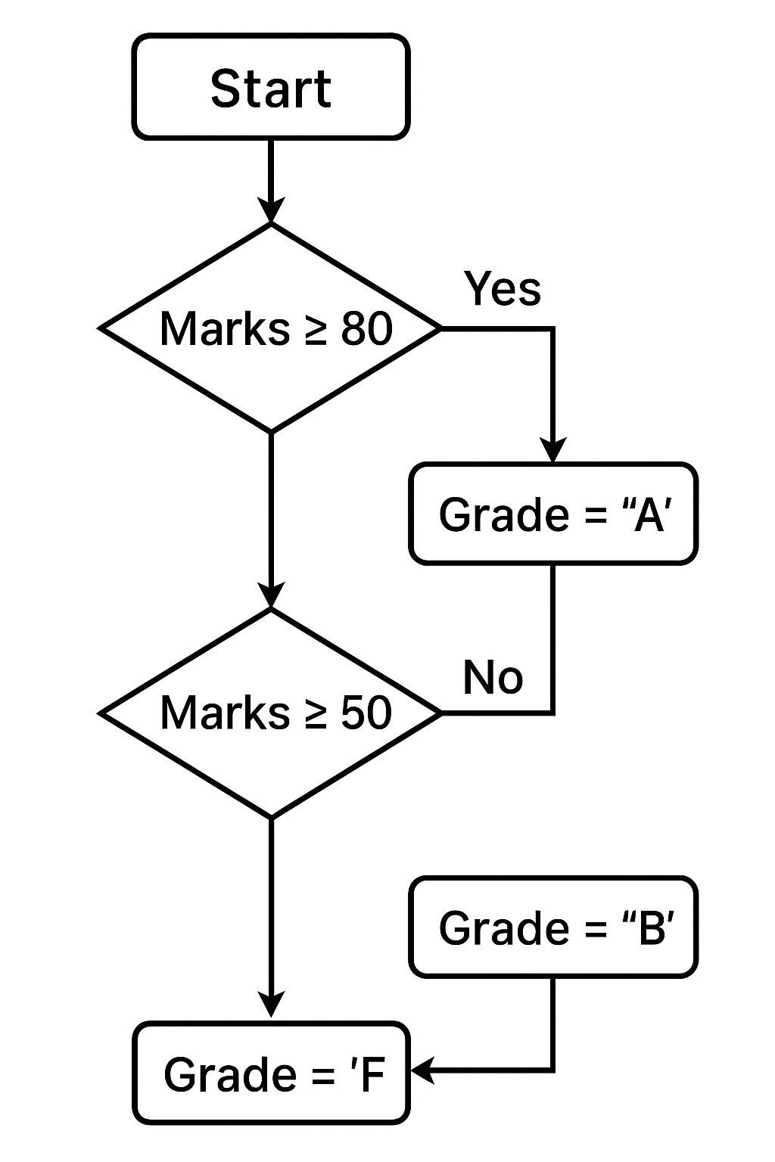

Q6: State one benefit of iterators in programming?(similar answer can be accepted)
Iterators allow looping through data structures like lists or arrays easily without needing to manage the loop counter manually.

Q7: Identify which programming construct(s) should be used.
Scenario 1 (Traffic Light Simulation): Selection (If-Else statements).
Scenario 2 (Printing Even Numbers): Iteration (Loop).

Q8: Why do we use variables in programming?(similar answer can be accepted)
Variables are used to store data values that can be used and changed during program execution.

Q9: Write a statement to check if marks ≥ 80.
if marks >= 80:

Q10: If x = 5, y = 3, what will be the value of:
z = x + y → 8
z = x * y → 15

Q11: Which block is used to give a starting value in Scratch?
Answer: c) Set [variable] to ()

Q12: Operator Challenge
A) Sort the Expressions:
1. 9 – 3 → Arithmetic
2. < 2 → Relational
3. 6 / 2 → Arithmetic
4. 7 >= 7 → Relational
5. 10 % 3 → Arithmetic
6. 5 == 4 → Relational
7. 8 + 1 → Arithmetic
8. 15 != 15 → Relational
B) Fill in the Operator:
1. 4 + 6 = 10
2. 3 == 3 = True
3. 15 / 3 = 5
4. 12 * 5 = 60
5. 9 > 7 = True

Q13: Ali’s Scratch Game
Answer: A) The 'Jump' block is a procedure, and the score sprite and coin sprite are interacting with each other.

